AIM

To develop and deploy a simple Students Attendance System as a Software-as-a-Service (SaaS) application using Microsoft Azure, with fields like Student Name, Course, Present, Absent, Course Attendance, OD (On-Duty) Request, Grade, and Attendance Percentage.

PROCEDURE

1. Login to Azure Portal
   * Go to https://portal.azure.com and sign in with your Microsoft Azure credentials.
2. Create a Web App (SaaS Deployment)
   * From the Azure dashboard, click Create a Resource → Web App.
   * Provide details:
     + Subscription: Your Azure subscription
     + Resource Group: Create new (e.g., AttendanceSystemRG)
     + App Name: studentsattendancesaas
     + Runtime Stack: Select Python, Node.js, or PHP
     + Region: Choose nearest region
   * Click Review + Create and deploy.
3. Develop Attendance Application
   * Build a simple web-based form with fields:
     + Student Name
     + Course
     + Present Days
     + Absent Days
     + OD Request (Yes/No)
     + Grade
   * Add backend logic to calculate:
     + Total Attendance = Present + OD Days
     + Attendance Percentage = (Total Attendance / Total Working Days) × 100
     + Auto-assign grade based on percentage (e.g., >90% = A, 75–89% = B, etc.).

*(You can create this using HTML + JavaScript or Python Flask and deploy on Azure Web App.)*

1. Deploy the Application to Azure
   * Use Azure CLI, VS Code deployment, or GitHub Actions to push code to Azure.
   * Test application on the Azure-provided URL (e.g., https://studentsattendancesaas.azurewebsites.net).
2. Access as SaaS
   * Share URL with faculty and students so they can access and update attendance online, demonstrating the SaaS model.

OUTPUT:

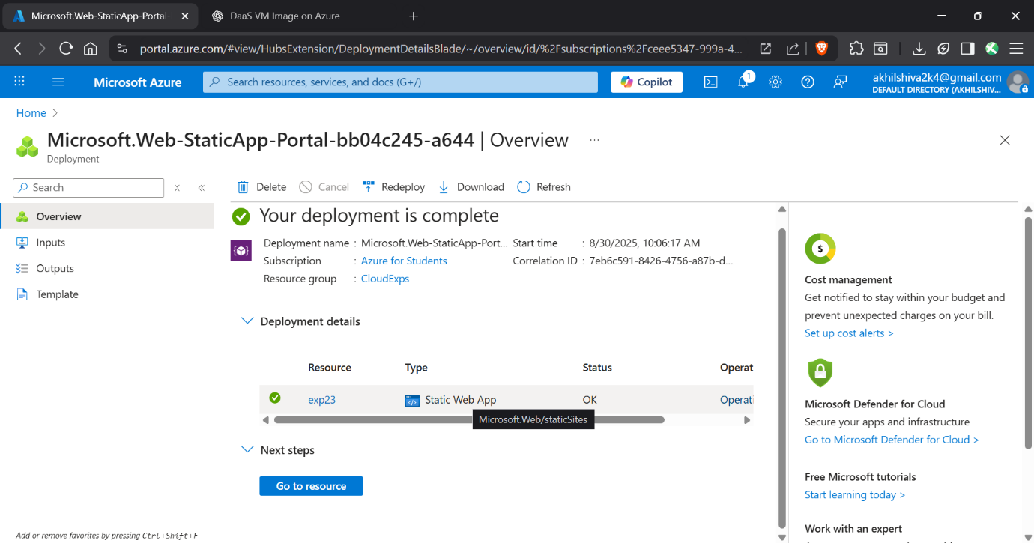

RESULT

The Students Attendance System was successfully developed and deployed as a SaaS application on Microsoft Azure.

* Users could enter student details, mark attendance, approve OD requests, and view attendance percentage.
* The system automatically calculated attendance percentage and displayed grades.
* The application was accessible online from any device, fulfilling the SaaS requirement.